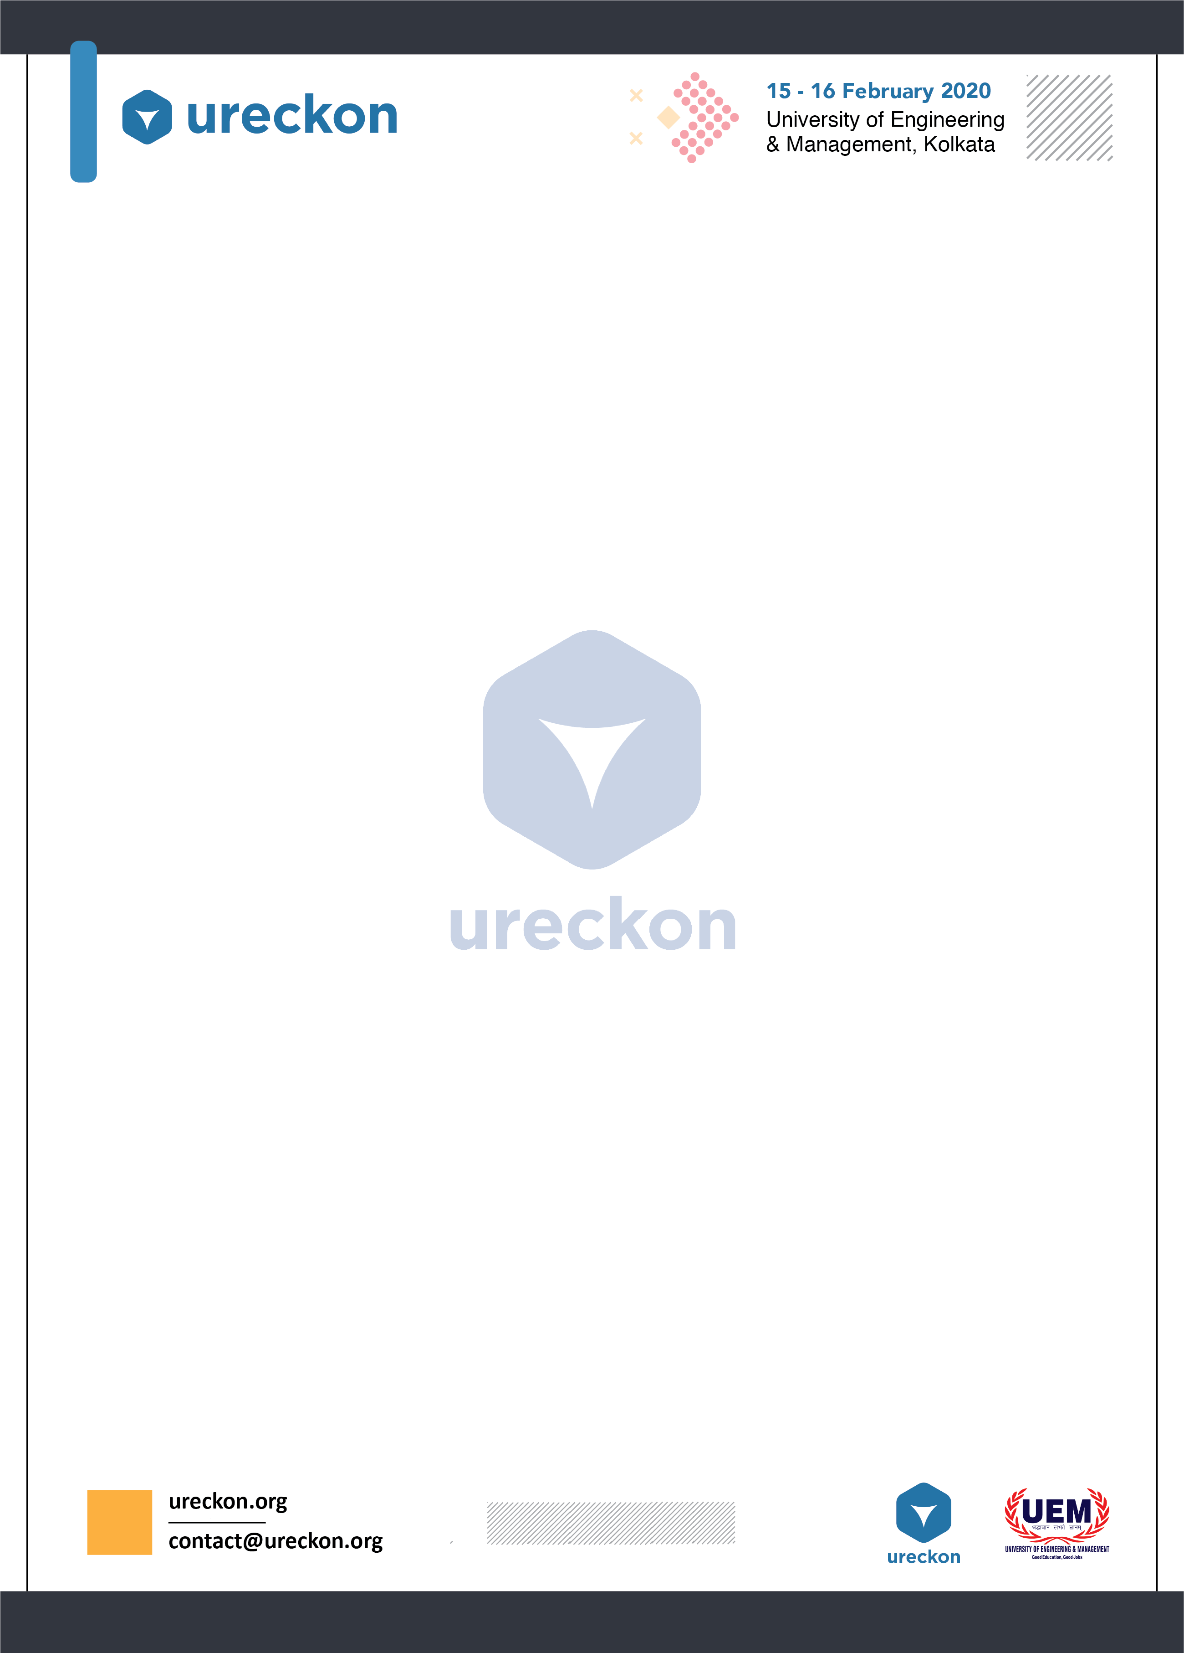

Dirección (LINE FOLLOWER)

*He who is a good follower can be a good leader.*

**Type**: Technical (robotics) ECE

**No. of team members**: FOUR (4)

**Event Description:-**

The Line follower robot is a mobile machine that can detect and follow the line drawn on the floor through the maze. Generally, the path is predefined and can be either visible like a black line on a white surface with a high contrasted color or it can be invisible like a magnetic field. Therefore, this kind of Robot should sense the line with its Infrared Ray (IR) sensors that installed under the robot.. After that, the data is transmitted to the processor by specific transition buses. Hence, the processor is going to decide the proper commands and then it sends them to the driver and thus the path will be followed by the line follower robot.

**Specifications:**

• The Robot must be strictly autonomous.

• The width of the black or white line will be less than 5cm

• Dimensions of the Robot should be less than 20cm*20cm*15cm ( lxbxh)

• The participants have to ensure that room lighting, photography etc. does not affect the functioning of the sensors.

• In case of tie, the design of the Robot may be considered.

• If the none of the Robots finishes the course, then the one which covered the longest distance in less time will be considered the winner.

• A power supply should be of maximum 12-15 V.

**Rules:**

• The Robot has to follow the black line on white background and complete the track in least possible time.

• Maximum 3 touches will be allowed for each round. ( Each touch make 5 sec penalty.)

• Maximum four Participants are allowed in a team.

• Team members can be from different colleges.

• If the machine remains immobile for respectable time then on the spot decision will be taken by the organizers.

**All the tracks will be shown at the time of competition.**

• Winners will be decided based upon the scores with minimum no. of penalities made. • Total score=(score of first round)/2+score of second round • In case of any tie ups,winners will be decided based on min. no. errors ie; bot with min. errors is the winner and if there is any ties further ,type of bot is considered which is more efficient. • Workshop bots are allowed but given less priority.

**Event Plan:-**

Round 1: Round one consists of basic track . Here the members are short listed based on time and charted to second round 2

.Round 2: This consists of complex circuit and also time taking. The team which completes tracing the track in the minimum time will qualify for round 3.

Round 3 : This consists of complex track followed by a maze which the bot has to trace its path through. The team which completes the track in minimum time will be announced winner.

**Event Organizers :**

TATHAGATA BANERJEE : 9477583958

SAYAN BOSE : 7278724340